Lab 02 Activity Sheet 02
Using MongoDB Compass/Atlas
Intro to CRUD Operations Solution

The objective of this tutorial is to understand how MongoDB CRUD operations work using MongoDB Compass/Atlas using the restaurants collection in the ample_restaurants database.
Lab Prerequisite:
Be familiar with the Week 2 lecture and resources prior to attending this activity.
Complete the Database Setup in Lab 02 Activity Sheet 01

CRUD operations are:
- basic methods of interacting with a MongoDB server
- primary ways to manage the data in the database.

CRUD operations in MongoDB comprises of the following:
CREATE
READ
UPDATE
DELETE

Prior to running the CRUD operations you will need to navigate to the restaurants collection in the sample_restaurants database:
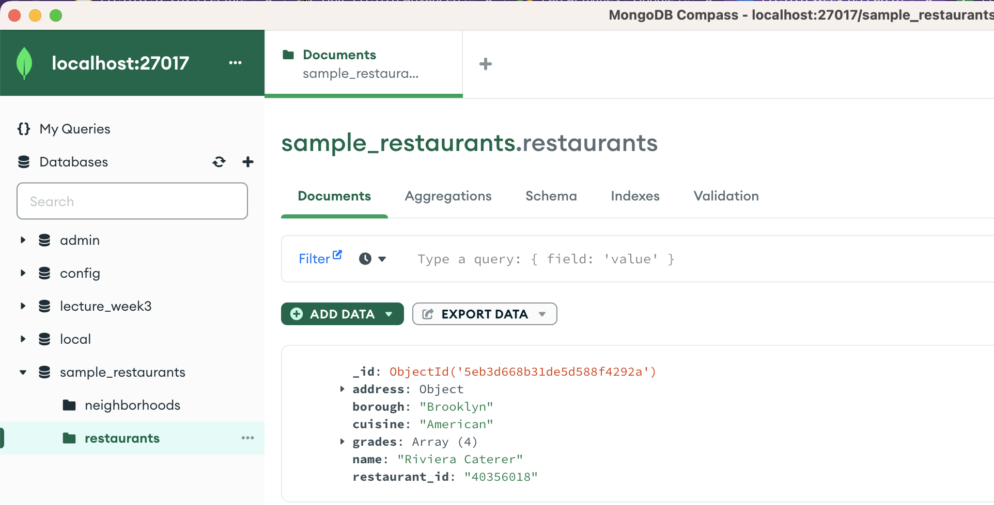

CREATE

is used to insert new documents in the database.
CREATE operations target a single collection
When creating documents if the specified collection doesn’t exist, the create operation will create the collection when it’s executed.

In the previous Lab 02 Activity Sheet 01you have already Inserted multiple Documents into the two Collections (neighborhoods and restaurants).

Tasks:
1. Insert the following document into the restaurants collection:
{ "address": {
"building": "1-B",
"coord": [ -73.98241999999999, 40.579505],
"street": "Stillwell Avenue",
"zipcode": "11224"
},
"borough": "Brooklyn",
"cuisine": "Indian",
"grades": [ { "date": { "$date": "2023-06-10T00:00:00.000Z" }, "grade": "A",
"score": 7}],
"name": "Little India Caterer",
"restaurant_id": "140356018" }
To insert a single document into a collection using the GUI, you may use the following ways:
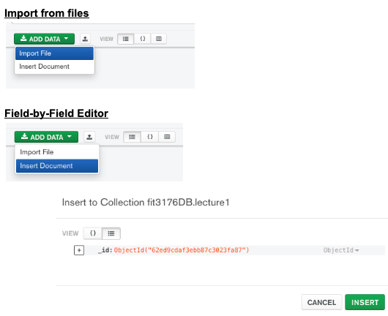
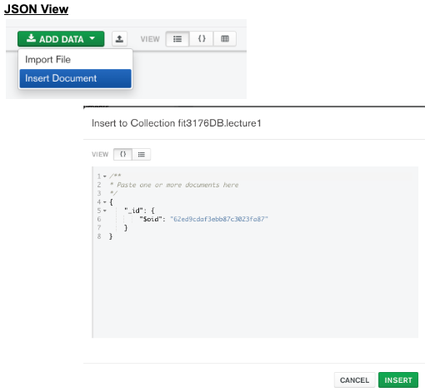

Figure: Inserting a single documen into a collection
For the _id allow MongoDB to set an automatic Object Id ($oid)

You can use the document clone feature to clone and modify {"restaurant_id": "40356018"}

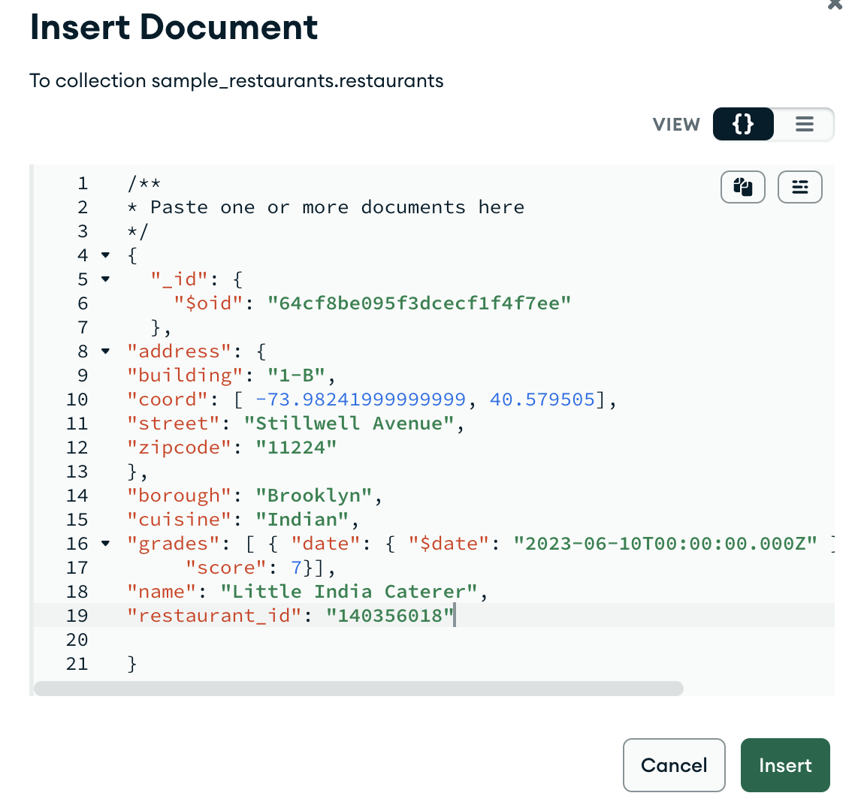
READ

is used to query a document in the database.
READ operations uses query filters and criteria (find(), project()) to retrieve documents
Cursor Methods (e.g. limit(), skip(), sort(), collation(), maxTimeMs() etc.) can be used to change how many results are returned.
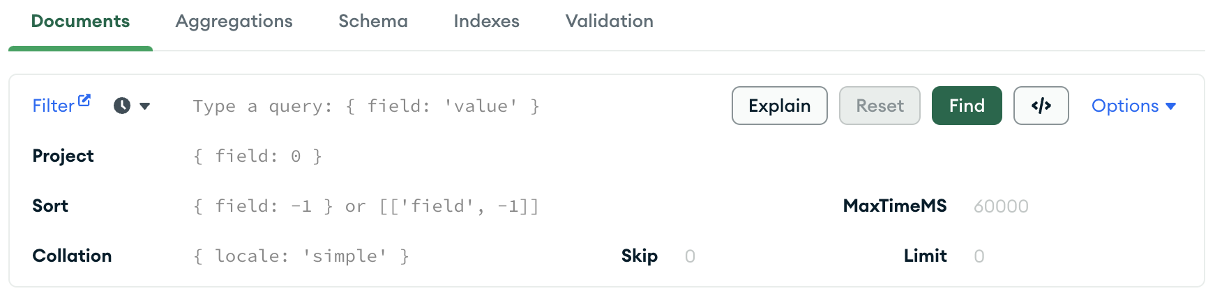
Figure: MongoDB Compass/Atlas GUI Query Bar

Query Bar Options | Purpose | Example (MongoDB Shell Code)
Find | finds documents that match a set of selection criteria | db.restaurants.find({borough: 'Brooklyn'})
Project | can specify which fields to return in the resulting data. By default, all fields are returned | db.restaurants.find({borough: 'Brooklyn'},  {borough: 1, _id: 0})
Sort | orders the documents in the result set | db.restaurants.find({borough: 'Brooklyn'})  .sort({borough:-1})
Skip | controls the starting point of the results set. | db.restaurants.find({borough: 'Brooklyn'}).skip(1)
Limit | limits the number of documents in the result set. | db.restaurants.find({borough: 'Brooklyn'}).limit(6)
Collation | allows users to specify language-specific rules for string comparison, such as rules for letter case etc | db.restaurants.find({borough: 'Brooklyn'})  .collation({locale: "en_US"})
MaxTimeMS | sets the cumulative time limit in milliseconds to process query bar operations.  If the time limit is reached before the operation completes, Compass interrupts the operation. | db.restaurants.find({borough: 'Brooklyn'}).maxTimeMS(5)

Table: MongoDB Compass/Atlas GUI Query Bar Options

Tasks:

Given that each document in the restaurants collection represents a restaurant, use the restaurants collection to retrieve the results of the following queries:
  - Display all restaurants serving American cuisine.
FILTER: { "cuisine":"American" }
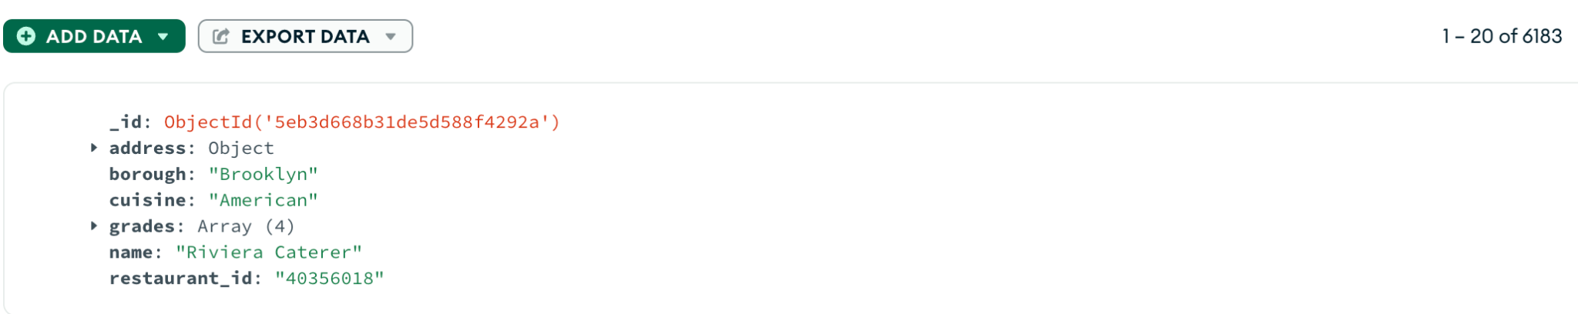

  - For all restaurants in the Brooklyn borough display only the cuisine field sorted in reverse alphabetical order
FILTER: { "borough":"Brooklyn" }
PROJECT: { "cuisine":1 }
SORT: {"cuisine": -1}
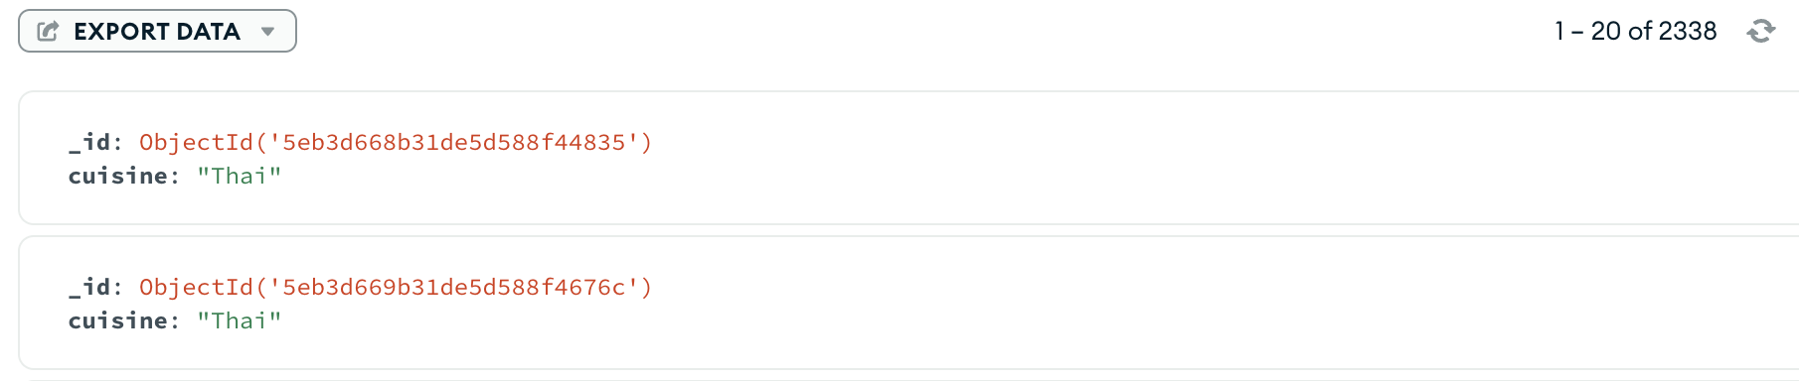

  - Display the name, address and cuisine for all restaurants excluding the _id from the results.
PROJECT: { "name":1, "address":1, "cuisine":1, "_id":0 }
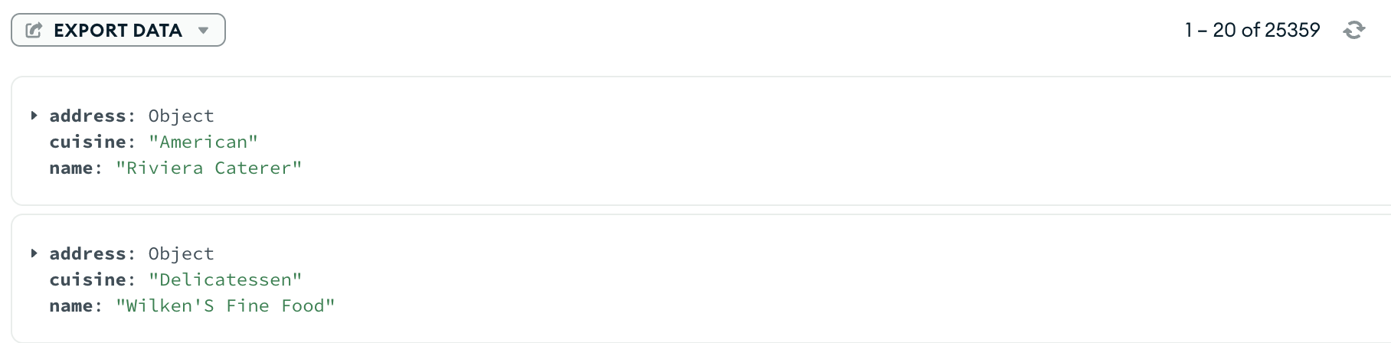

Using the Query and Projection Operators answer the following:

  - Display the names of all restaurants who had a grades score of greater than or equal to 90 excluding the _id from the results.
FILTER: {"grades.score": { $gte: 90 } }
PROJECT: { "name":1, "_id":0 }
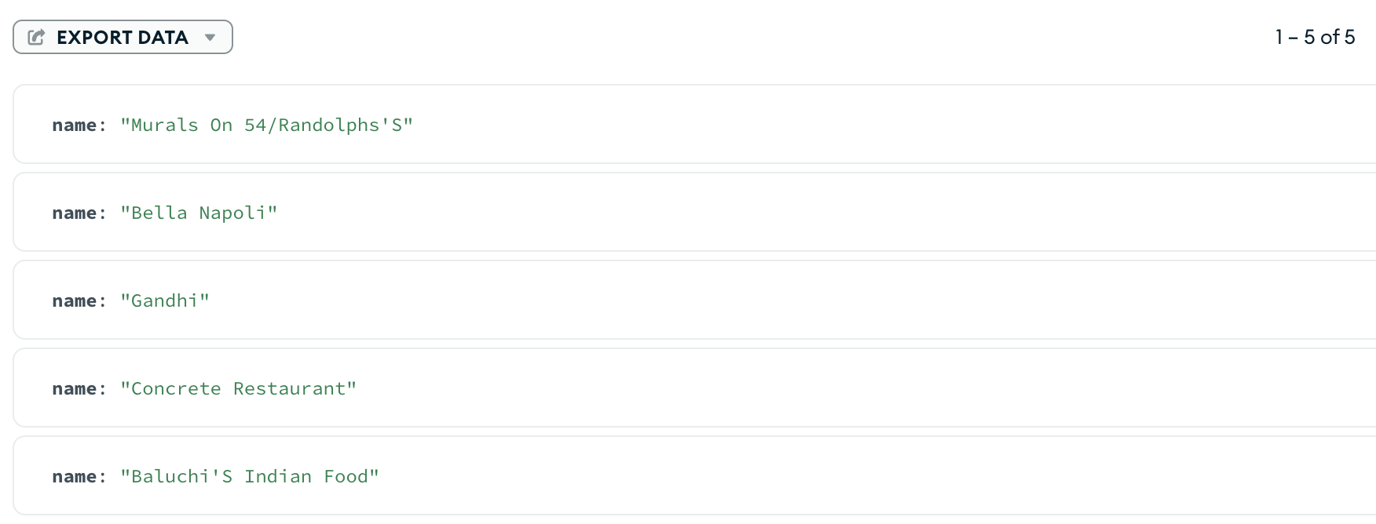

  - Among the restaurants who had at least one grades score of less than 90 (note that grades is an array and can have other scores greater than 90) , display the name of the restaurant which had the highest score (excluding the _id).
FILTER: { "grades.score": { $lt: 90 } }
PROJECT: {"name": 1, "_id": 0}
SORT: { "grades.score": -1 }
LIMIT: 1
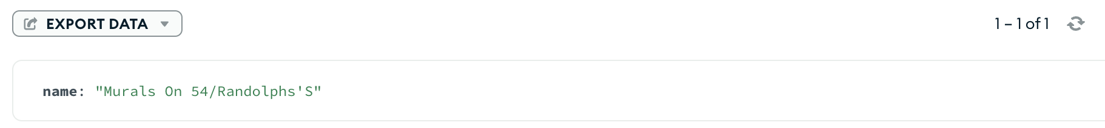

  - Display all fields of the 4th highest grades score restaurant who had a grades score equal to 50 and did not serve American and Indian cuisine.
FILTER: {'grades.score': {$eq: 50}, "cuisine": {$nin:[ "American", "Indian" ]}}
SORT: { "grades.score": -1 }
SKIP: 3
LIMIT: 1
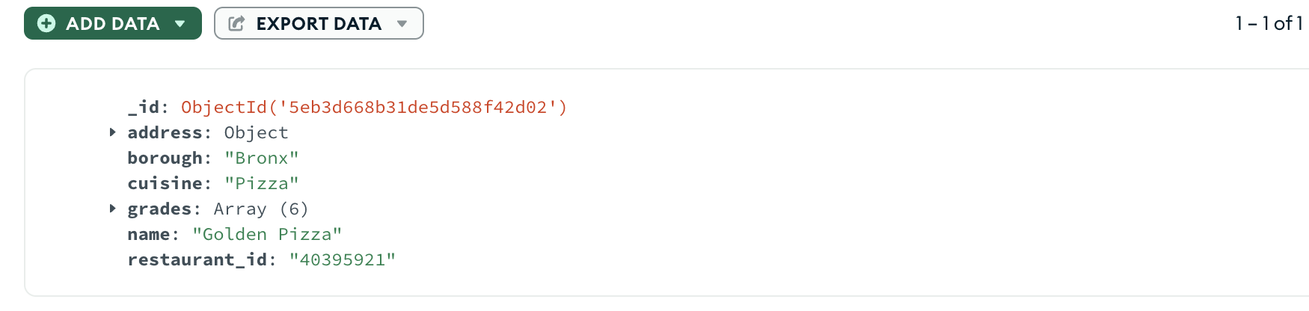

UPDATE
is used to modify existing documents in the database.
Similar to CREATE, UPDATE operations operate on a single collection, and they are atomic at a single document level.
An update operation takes filters and criteria to select the documents you want to update.
To track updates the Last Modified Date can be added
Note: when updating documents, updates are permanent and can’t be rolled back. This applies to delete operations as well.
Task:
Update the grades date for the restaurant with restaurant_id 40356018 and score 5 to 2014-06-11.
Note: add a field called lastModified (with the value as today’s date) in each to keep track of the update Use the date data type and insert the value with today’s date.

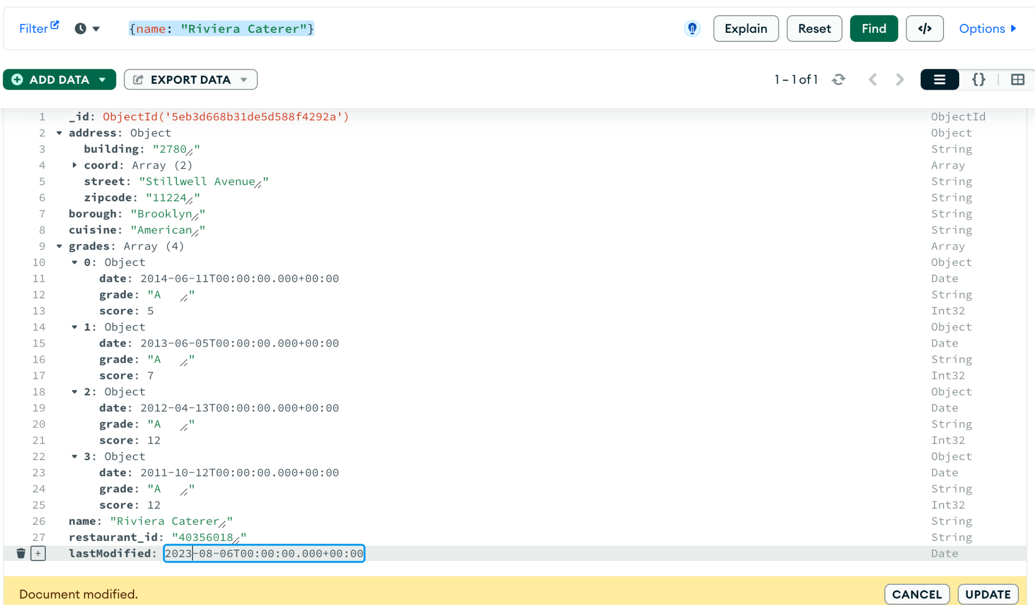

DELETE
used to remove documents in the database.
DELETE operations operate on a single collection, like update and create operations.
DELETE operations are also atomic for a single document.
Filters and criteria can be used in DELETEs to specify which documents to delete from a collection.
The filter options rely on the same syntax that read operations utilize.
Task:
Find and remove the document(s) with Missing borough, Other cuisine and no grades

FILTER: { "borough":"Missing", "cuisine": "Other", "grades": {$size: 0}}

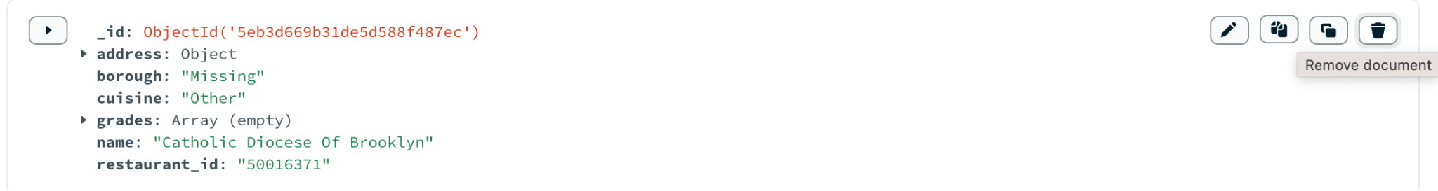

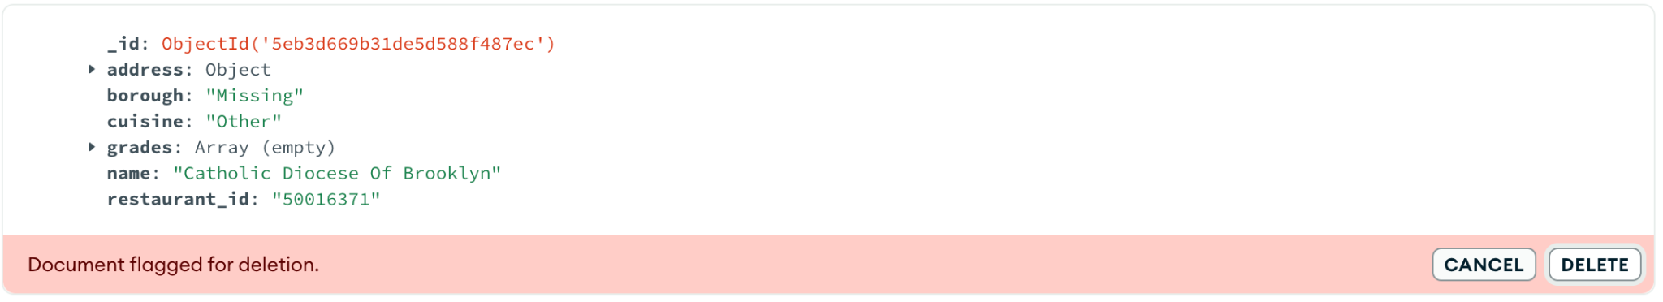

Challenge Questions:
Q1. Use the MongoDB documentation to list the components of the 12-byte ObjectId().

A. The 12-byte ObjectId consists of:
- A 4-byte timestamp, representing the ObjectId's creation, measured in seconds since the Unix epoch.
- A 5-byte random value generated once per process. This random value is unique to the machine and process.
- A 3-byte incrementing counter, initialized to a random value.

THE END

